Meal ideas and planning for a hike:

For Breakfast
Cereals with milk (can buy the variety pack)
Oats / porridge
Up and go

For lunches
- Salami and cheese on a wrap or crackers
- Nutella on a wrap
- Any spread on a wrap
- Salmon tempters on a wrap (preferable over tuna because it comes in a sachet rather than a tin and hence the rubbish is a lot easier to carry out)

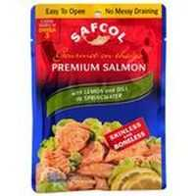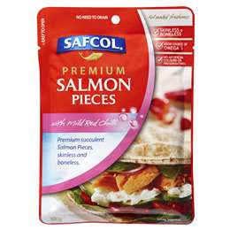

I prefer wraps as they don’t go stale like bread. Crackers such as Cruskits also work and these can be packaged up in chinese containers to stop then getting broken.

For Dinner
Prepackaged meals (purchased from Asian isle of supermarket). Note the one on the left is only from Woolies.

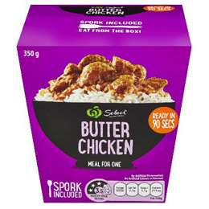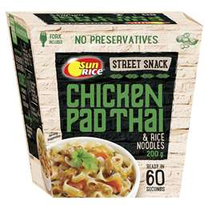
These are very handy as they create very little mess to clean up (the packages inside can be boiled in the billy) to heat them up and then eaten straight from the box. There are quite a number of different flavours (satay chicken, massaman beef etc)

Dehydrated meals (can be bought from any outdoor shop) – a little expensive but quite tasty

Scroggin / snacks
Scroggin is a mix of nuts, dried fruit & chocolate to be eaten along the trail. Most people will develop their own blend or you can buy pre-made trail mix off the shelf at a supermarket. Alternatives to scroggin might include muesli bars, variety pack or mini pack of chocolates (mars bars etc).

The key issue is that it needs to be nutritious and relatively lightweight remembering that all the packaging also needs to be carried out.

2 minute noodles by themselves are not considered an adequate meal but they can be used as support to something more nutritious.

Also fresh food/meat does not last in the bush very well particularly in summer. The bush is not a great place to have food poisoning.

Zip lock bags in a variety of sizes are great as they can double to carry the food in & then used as a sealable rubbish back to carry the sticky wrappings back out.

Size and weight matter so dried ingredients over wet (e.g. powdered milk rather than long life milk, dried fruit over real fruit). The longer the hike the more important this becomes.

Planning your menu and food

Hiking trip – 2 days
 | Friday | Saturday | Sunday
Breakfast | N/A | N/A | Cereal  Coffee
Lunch | N/A | Pre-made  Ham & salad roll  Fruit | Salami &  Cheese on wrap  Fruit
Dinner | N/A | Pre-packed meal  Cup-a-Soup  Dessert  Coffee | N/A
Snacks |  | Scroggin (refer notes)  Marshmallows | Scroggin

Breakfast | Lunch | Dinner | Other
Weet bix x 2  Powdered Milk  Coffee bags x 3  Sugar bags x 5 | Salami  Wrap  Cheese  Dried Apple | Butter Chicken  Fruit & custard  Cup-a-Soup | Scroggin  Marshmallows

Puri-tabs / Aqua Prove (water purification)

Notes: Friday is included as quite often dinner Friday night may need to be catered for due to the drive to the location

The shopping list is put together for those items that you don’t already have in your pantry

Shopping List

Dairy/fridge
Salami
Cheese

Shelves
Powdered Milk
Wraps
Butter Chicken packet
Dried apples
Marshmallows
Scroggin

